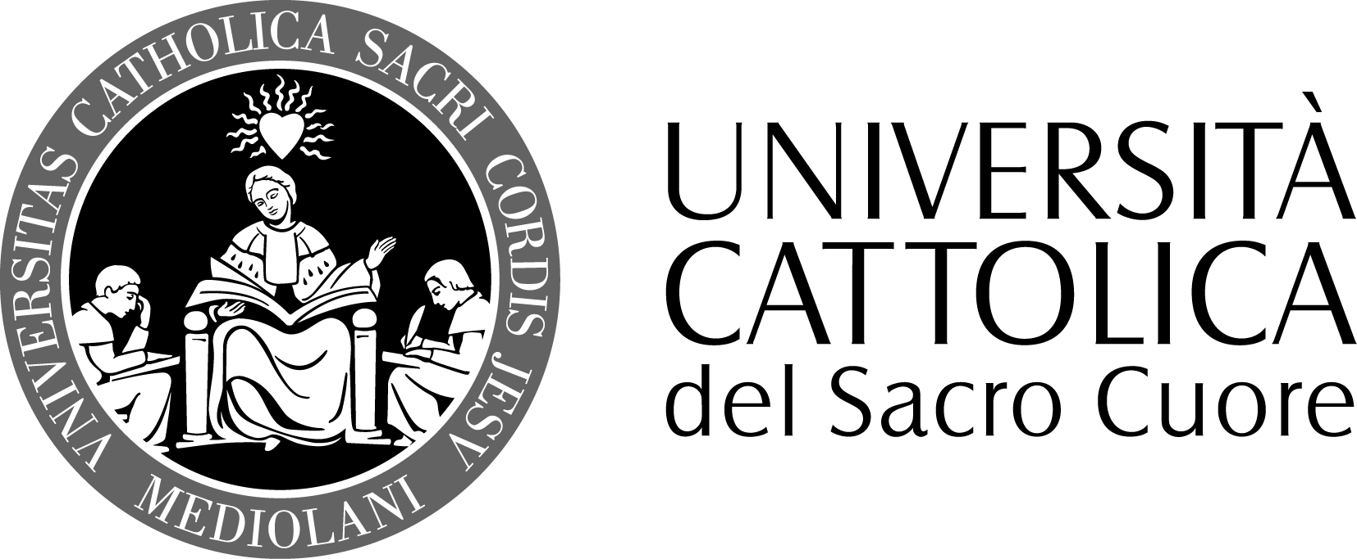

FACOLTA’ DI SCIENZE DELLA FORMAZIONE
DOTTORATO IN PEDAGOGIA EDUCATION
XXVIII

Name and Surname Jos Beelen
Supervisors
Prof. Dr. Hans de Wit
Ass. Prof. Dr. Betty Leask
Prof. Renata Viganò

Topic: The implementation of Internationalisation of the curriculum in a global comparison

The project aims to research and analyse implementation strategies for internationalisation of the curriculum within their specific contexts as well as making a comparison across universities and regions.

General framework / context. Since the middle of the nineties of the last century, Internationalisation at Home has received increasing attention. Internationalisation at Home is now recognised as one of the two main streams in internationalisation, next to the traditional internationalisation abroad (Knight, 2008). At the same time, it has become apparent that IaH has remained largely a policy item and that universities struggle to implement a meaningful international dimension into their programmes. In her PhD research, Van der Wende already focused on the internationalisation of curricula and facilities for internationalisation at Dutch research universities in an international comparison. The present research will focus on Universities of Applied Sciences with their stronger orientation on the world of work. The particular situation of Dutch UAS will be the core of the research. Moreover, the focus on internationalisation of the curriculum has changed considerably since the development of the concept of Internationalisation at Home as has the insight into the obstacles to its implementation.

Reasons, aims, objectives. In 2009, the School of Economics and Management at the Amsterdam University of Applied Sciences decided to implement a compulsory international semester with English as the language of tuition in all its Dutch medium full time programmes. The international semester should enable all students to acquire the intercultural and international competences needed in their future professions. The School of Economics and Management identified a variety of issues when implementing its policy. These have become apparent through the monitoring of the implementation process in the Dutch medium programmes of the School of Economics and Management. In 2010, the university as a whole also adopted a strategic internationalisation policy with a focus on intercultural and international elements in the home curriculum for all students. This means that all students should have at least 30 EC education with an intercultural and international focus. In November 2011, the policy was redefined as “learning and working in an urban international environment”. The university as a whole also encountered obstacles to implementation. A number of these have also been identified in surveys of the International Association of Universities, which concluded that lack of financial resources, lack of involvement of academic staff, lack of expertise in the internationalisation process and lack of foreign language skills are the main internal obstacles to internationalisation.
The proposed research project aims to place to the situation at the Amsterdam University of Applied in a national, international and global context, with a particular focus on the role of English in internationalisation of the curriculum.

Research hypothesis. The implementation of internationalisation of the curriculum is facing a number of known obstacles at universities across the world. The latest research (Leask, 2012; De Wit & Beelen, 2012) suggests that these may be overcome by implementation in context and mainstreaming internationalisation of the curriculum into general educational innovation. Yet, Leask’s framework and process model are not explicitly linked to any model of action research. It is therefore not known if this model, which is claimed to be effective, does correspond with any of the known models of action research (Reason & Bradbury, 2008) or –more specifically- participatory action research (PAR) (Kemmis & McTaggart, 2005). Therefore, it is not evident if the Australian approach is successful in other contexts.
Leask places considerable emphasis on the relevance of the ‘imagination’ phase in her process model, which raises questions on the role of the facilitator in the process and to what extent this is determined by him being an outsider or insider (or being considered as such), the role of preliminary questionnaires (Leask’s Questionnaire on Internationalisation of the Curriculum), the interaction with academics and his dealing with systemic constraints in the university setting. Also here, it is not elaborated what this role should be, how it may change in different geographical and disciplinary contexts and how this could impact the success of the implementation process.

Methods (research device, planning, tools, instruments). General methods used: (semi) structured interviews, document analysis, participatory action research during coaching and workshops at Dutch and international universities and international networks and associations.

Expected results. Insights into the way universities deal with implementation of Internationalisation at Home/internationalisation of the curriculum and the success factors involved.

