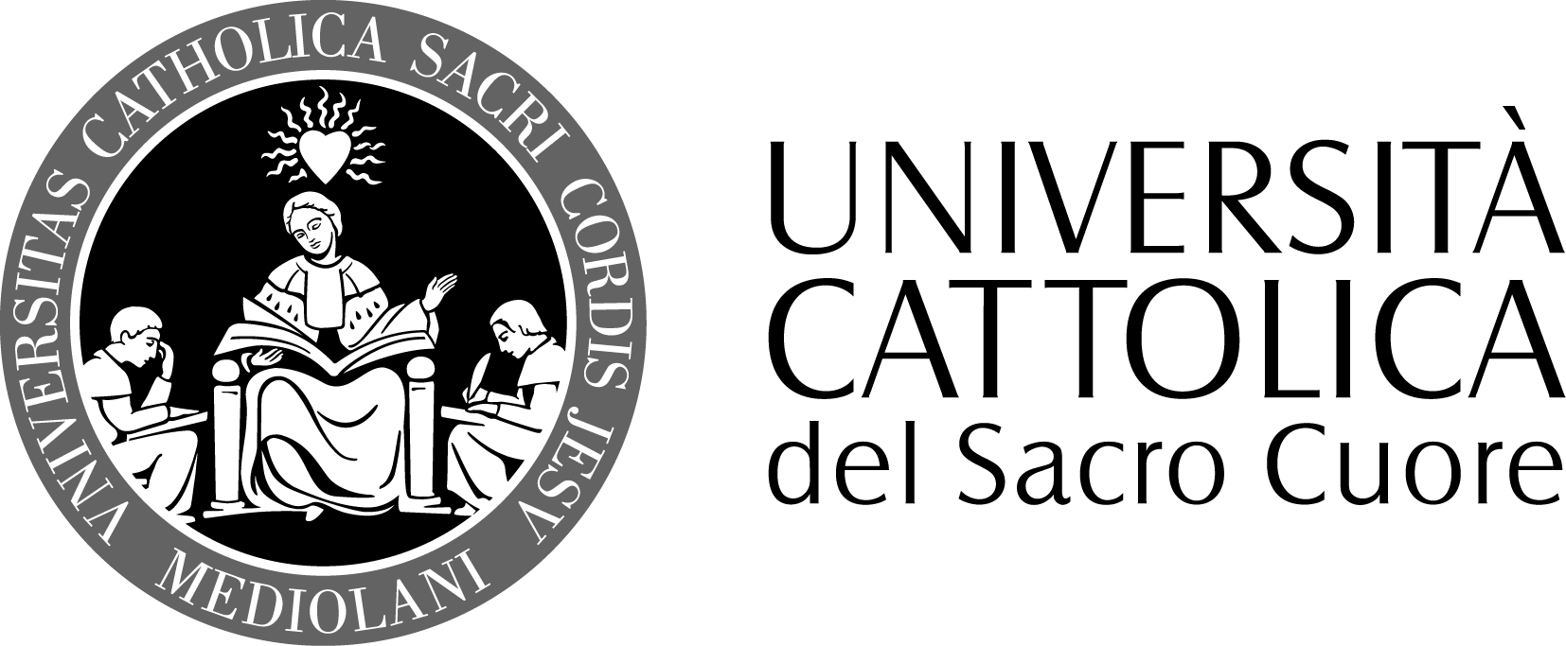

FACOLTA’ DI SCIENZE DELLA FORMAZIONE
DOTTORATO IN PEDAGOGIA EDUCATION
XXVIII

Name and Surname Gabriele Weber Bosley
Supervisors
Prof. Dr. Hans de Wit
Prof. Renata Viganò

Topic: Action Research towards a Sustainable Pedagogy: Development of Intercultural Competence in the Context of Institutional Commitment to Internationalization and the Preparation of Students for Global Citizenship

Colleges and Universities around the globe are increasingly embracing the notion of preparing students for Global Citizenship in their institutional mission and vision statements. What is often missing is a definition of the concept of Global Citizenship and what role the development of intercultural competence plays in this. While the inclusion of developing a global perspective as part of one’s educational journey seems as appropriate today as the idea of global citizenship was already in ancient Greece, it is a concept that today is best examined from the vantage point of the development of intercultural competence. Over 30 instruments and inventories are available to examine and quantify intercultural competence in addition to qualitative and experiential measures. From advocates representing such organizations as the Association of American Colleges and Universities (AAC&U), the Association of International Administrators (AIEA), the Brookings Institution, the International Association of Universities (IAU), the Modern Language Association (MLA), to corporate America’s expectations of the 21st century workforce, to individual voices like public opinion analyst, Daniel Yankelovich, we hear demands such as, “We need to understand other cultures and languages.” or, “Our whole world must become less ethnocentric, less patronizing, less ignorant of others, less Manichaean in judging other cultures, and more at home with the rest of the world. Higher education can do a lot to meet that important challenge.”
The objective of this study is the assessment of the impact of various intercultural experiences on the development of intercultural competence. A mixed methods approach will be utilized by employing questionnaires, interviews, and qualitative data from 6 years of student writing samples, along with pre and post sojourn assessment utilizing the Intercultural Development Inventory (IDI), developed by Bennett and Hammer, as an empirically valid measure of intercultural sensitivity, the main source of quantitative data. The theoretical frameworks used include social contact theory (Allport, 1954; Pettigrew&Tropp, 2006), experiential learning theory (Dewey, J. (1904), transformational learning theory (Mezirow, 1991), intercultural communication theories (Hall, 1956, 1976; Hofstede & Hofstede, 2005; Hofstede, Hofstede, & Minkov, 2010), the Developmental Model of Intercultural Sensitivity (Bennett, 1993), and cultural immersion intensity factors (Paige, 1993).

The study will examine the genesis of assessment (both qualitative and quantitative) in intercultural learning environments, explore the validity of the IDI, followed by a focus on the pedagogy developed to construct the author’s own intervention model for the development of intercultural competence, known in the international educators’ community as the Bosley/Lou Intentional Targeted Intervention Model (ITIM). Data of various student cohorts will be analyzed in the context of national and international data from the field of international education vis-à-vis the paradigm shift in learning and outcomes assessment in education abroad over the past 100 years. A detailed examination of the author’s ITI Model compared to other intervention models will be incorporated into this study from previously published book chapters and papers by the author, along with a review of how this data compares to control groups.

Since 2008, the author has access to valuable data generated by administering the IDI to a 2008 Bellarmine University Freshman Cohort as part of the University’s internationalization strategy. The University then followed these Freshmen over the course of their 4 years of undergraduate study. This data will be analyzed closely as to the individual experiences students had during their 4 year college journey. Students have been coded by the author since 2008, reflecting a variety of “intercultural encounters”, allowing for a broad analysis of levels of development of intercultural competence, ranging from 4 years spent in classrooms on campus to students engaged in a variety of off campus experiences such as service learning in local immigrant communities, service learning travel to regions in the U.S. or abroad, to short term and long term study abroad, to American “island program” experiences, to direct enrollment settings at over 150 partner universities abroad. While analyzing a possible relationship between a student’s IDI score and a plethora of intercultural experiences ON campus (i.e. international student roommate, peer mentorship for internal inbound students), this study will mainly focus on the development of intercultural competence for the 4 year cohort vis-à-vis the impact of the university’s various internationalization initiatives, particularly immersion abroad with semester long intervention via the ITI Model.

Peripherally, the study will also attempt to examine the IDI against the Global Perspectives Inventory (GPI) which is aligned with the institution’s strategic plan for internationalization with focus on the development of Knowledge, Skills, and Attitudes, i.e. the study will explore a possible correlation between the IDI results and the attitudinal component of the GPI. According to the developer of the GPI , Dr. Larry Braskamp, (Loyola University, Chicago), no one has studied this potential relationship at this point, and it is thus an eagerly awaited data set for the field of intercultural competence assessment in international education in the U.S. and abroad.

Based on the findings of the IDI and GPI results, the author may be in a position to make pedagogical and curricular recommendations to Bellarmine University, as well as to the intercultural education community at large and turn this research into action for a sustainable pedagogy.

